

**Department of CSE**

**CSE209 Lab**

**Course Name: Electrical Circuits**

**Course Code: CSE209**

**Section No: 2**

**Experiment No: 03**

**Name of the Experiment:** Bias Point Detail Analysis of DC Circuit with Independent Sources Using PSpice Schematics.

**Date of submission:**

Student’s Name: Md Abdul Ahad Rifat

Student’s ID: 2020-1-60-215

**Submitted to**

Rashedul Amin Tuhin

Senior Lecturer

Department of Computer Science and Engineering

East West University

**Objectives:**

1. To learn fundamentals of PSpice.

2. To analyze Bias Point Detail of DC circuit using PSpice Schematics.

**Circuit Diagram(s):**

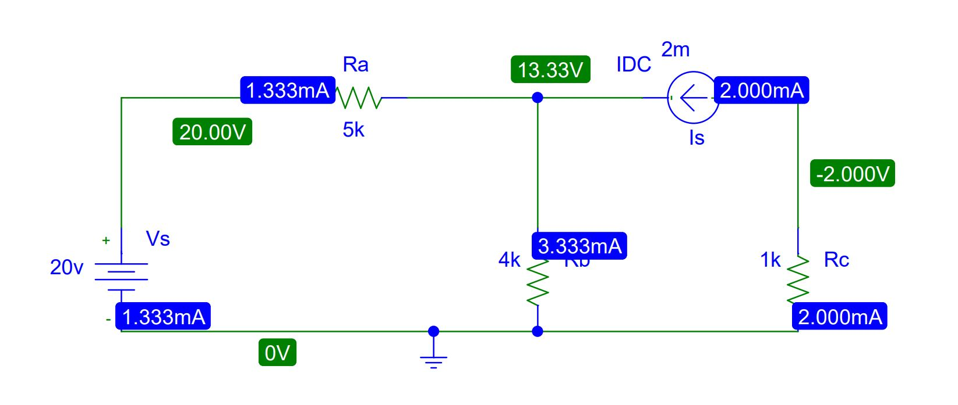

**Figure 1.Circuit Diagram for Experiment 3**

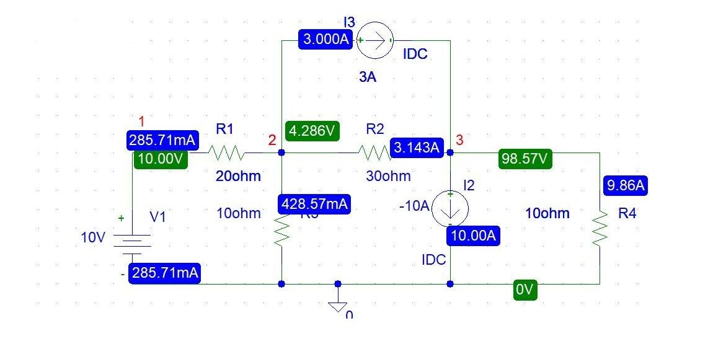

**Figure 2.Circuit Diagram for Experiment 3**

**Post-Lab Report Questions and Answers:**

1. Theoretically calculate all the currents and the voltages for the circuit shown in Figure 2.

**Answer:**

Applying KCL at node 2,

$$\frac{10-V_{2}}{20}=3+\frac{V_{2}}{10}+\frac{V_{2}-V_{3}}{30}$$

Applying KCL at node 3,

$$3+\frac{V_{2}-V_{3}}{30}=-10+\frac{V_{3}}{10}$$

Solving equation 1 and 2 we get,

$$V_{1}=10 v$$

$$V_{2}=4.286 v$$

$$V_{3}=98.57 v$$

$$I_{1}=\frac{10-V_{2}}{R_{1}}$$

$$=\frac{10-4.286}{20} A$$

$$I_{1}=258.71 mA$$

$$I_{2}=\frac{V_{2}-V_{3}}{R_{2}}$$

$$=\frac{4.286-98.57}{30} A$$

$$I_{2}=-3.1428A$$

$$I_{3}=\frac{V_{2}-0}{R_{3}}$$

$$=\frac{4.286-0}{10} A$$

$$I_{3}=428.57mA$$

$$I_{4}=\frac{V_{3}-0}{R_{4}}$$

$$=\frac{98.57-0}{10} A$$

$$I_{3}=9.86A$$

1. Compare the theoretical solution of the circuit shown in Figure 2 with the solutions obtained from PSpice.

**Answer:** There has been no change in theoretical calculation value and Pspice simulation value in Figure 2.

**Conclusion:**